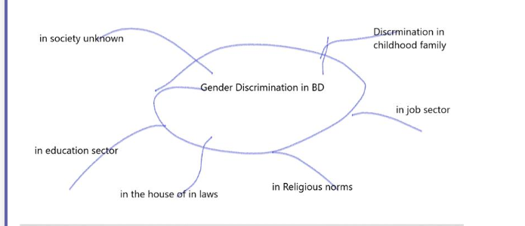

Introduction

Gender discrimination is a common concept in BD society. Here women are considered inferior to men. Men dominate the society as the stronger identity than women. Hence men can easily develop discriminatory practices throughout the society in any way they like. Moreover, the male domination and gender discrimination are also supported by our religious and cultural norms. In BD there exists gender discrimination in almost every sphere of life and it starts from childhood at home and continues through school college education life as well as job sector and after marriage in the house of in laws and actually remains in every sphere of life in society.

Essay Outline

Intro + Thesis Statement

Joined with each other

Thesis statement will be underlined to be differentiated

Without underline, the thesis statement will not be recognized or accepted

Introduction +Thesis Statement/Central Idea

Body Para 1

Main idea/TS 1 In family during childhood girl children are given less priority and facility and even in school also the girls are marginalized with the excuse of their feminine qualities as well as the narrow attitude of teachers and parents towards school and college going girls.

SD 1 Supporting Detail

SD 2

SD 3

Body Para 2

Main idea/TS ----Gender discrimination affects the workplace and the adult women most of the time have to suffer from negative and narrow attitude of the members of in laws in BD society.

SD 1

SD 2

SD 3

Conclusion

